5/26/15

Skin Graph-t

Excellent work on Problem 1. There’s some great mathematical reasoning here, especially in problems 3 and 4. Keep working on your proofs and explanations; some of your proofs have significant gaps, and a brief explanation would have improved your solutions to 7,8, and 9.--RK

Technical Writer: Dean Gladish

Engineer: Richard Yan

Reporter: Mitchell Mikinski

Conductor: Richard Yan

Morning Session: This morning we learned about Chromatic numbers of a graph which is the least amount of colors needed to completely color a graph. We also learned about Alpha or Independent numbers which is the largest order of an independent set. The clique or omega number is the size of the largest complete subgraph. Theta or the clique partition number is the smallest number of cliques you need to partition the graph. Dominant numbers are the set of dominant vertices where every other vertex is either neighboring to or a part of the dominant set. We also worked on some questions where we had to solve for chromatic, independent, clique, clique partition, and dominant set numbers.

Afternoon Session: This afternoon we worked with our new group for the first time. We got along well, and worked together to figure out the answers to the different problems. We started with number one. We each took a graph and worked together to check the conclusions we reached on our graphs (Example : Dean finished with his graph, Richard and Mitchell checked his solutions, mutatis mutandis). From here, we each found different problems that worked to our strengths, again checking our work and reaching a consensus on our answer before moving to our next individual problems. We finished the following problems: 1, 3, 4, 5, 6, 7, 8

1. for the first picture (from left) 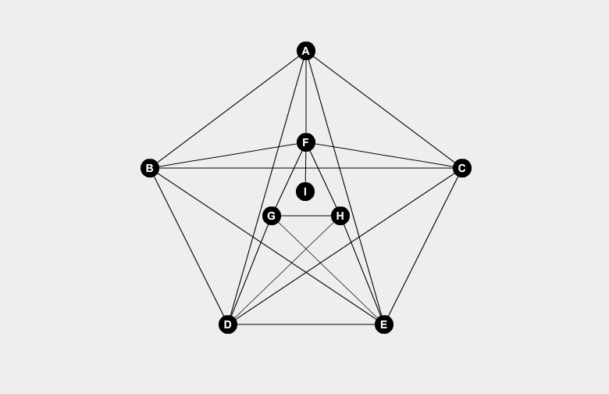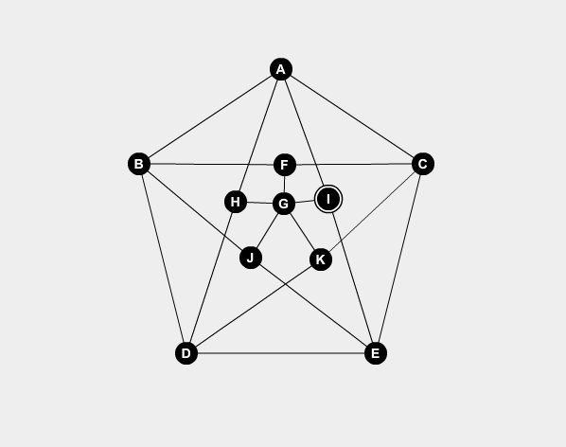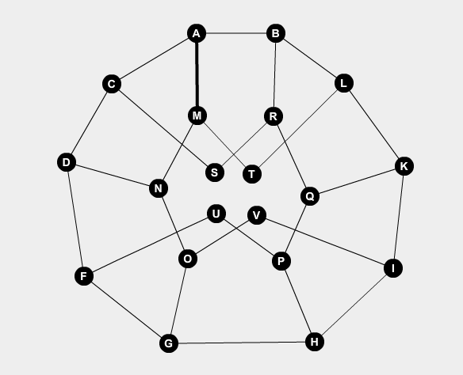

Chromatic #: 5, Alpha #: 2, Omega #: 5, Theta #: 2, Dominant #: 2

for the second picture

Chromatic #: 3. Alpha #: 8, Omega #: 2, Theta #: 10, Dominant #: 6

for the third picture

Chromatic #: 4, Alpha #: 5, Omega #: 2, Theta #: 6, Dominant #: 3

All of your answers match up with mine =] - Lizzy

2. No answer.

3. a. Assume you have a graph, G, that has $χ(G)≠k$, but is not k partite. That means the graph can’t be partitioned into k independent sets. However, if you consider each color an independent set, then G must have a chromatic number of k AND be k partite, as there are k colors, and thus k independent sets. Therefore a graph that has a chromatic number of k must also be k partite. ***Q.E.D.*** This is the right idea! You need a bit more explanation. Why does each color correspond to an independent set? Also, you don’t need to do this by contradiction; it’s quicker to prove it directly.--RK

b. 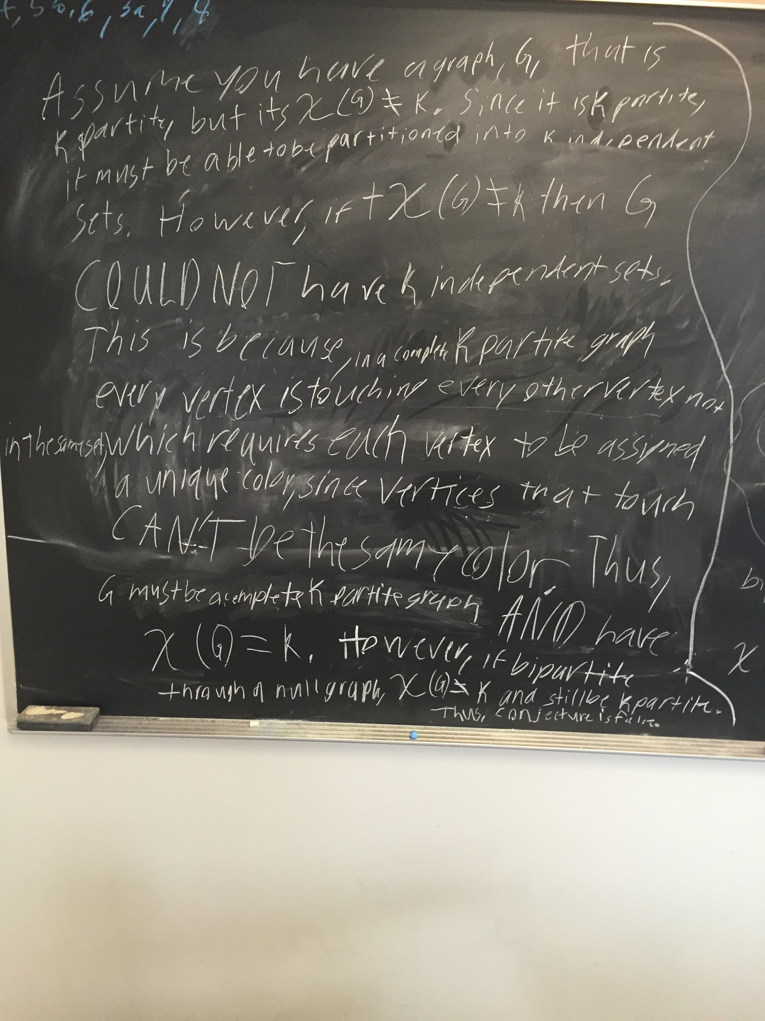

Interesting argument! I like that you explored what happens with complete bipartite graphs. Be careful to state exactly what you’re assuming, and what you’re trying to prove. The sentence “if is not equal to k, then G could not have k independent sets” isn’t true! Lots of graphs have both of these properties. You need to state ahead of time that you are referring specifically to complete k-partite graphs.  
  
Also, please do type up your solutions. Your picture of the board is hard for me to read, and I don’t think I would be able to understand it if we hadn’t discussed this problem during the homework session.

4. 4 colors; if we start at the center of the graph, we see a country. We can then color this red. We can then color the adjacent tile yellow. To the left and down, we need a third color as two same colors cannot be adjacent. As we have been forced to use three colors, we can see that the country in question necessitates the use of a fourth color. As four colors have been proven to be sufficient in the coloring of a (Planar) map, we can assume that four colors are needed.

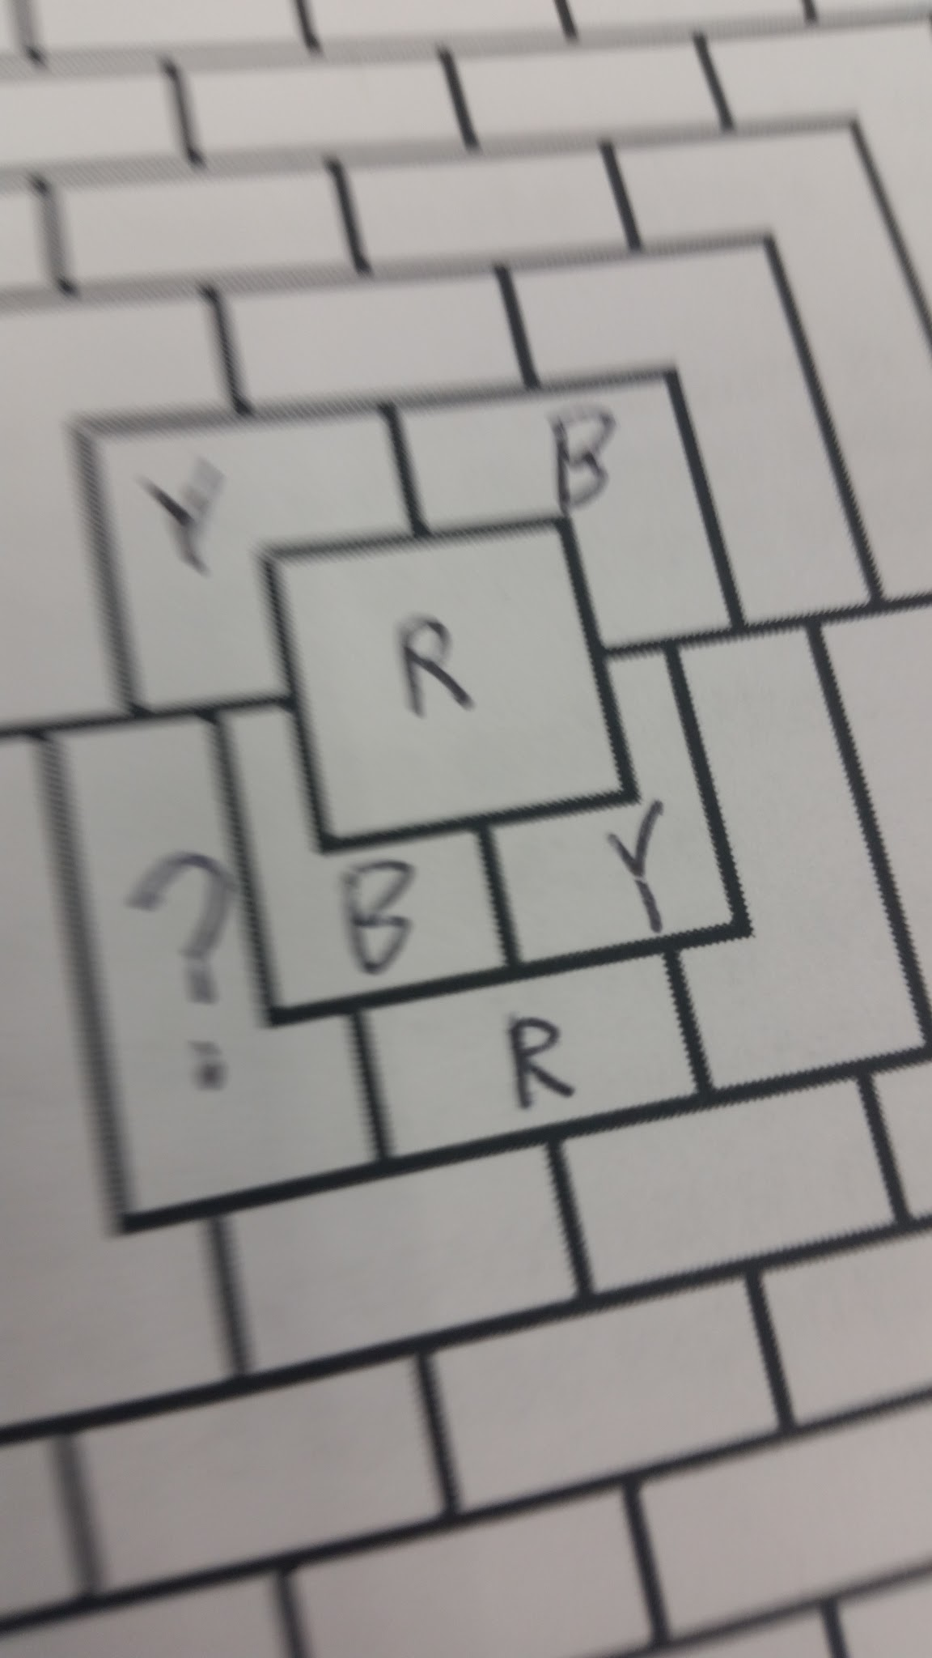

* Four looks to be correct, good reasoning, however the proof was for planar graphs, with this is, so you used it correctly, but next time make sure to state that it only is proven for planar graphs. - Lizzy

5. a. dom(G); to represent a person who hates another person, we draw an edge. The smallest dominating set, represented by dom(G), will have no edges between the vertices. Therefore we need the smallest dominating set in order to ensure that we invite no one that s/he hates.

* I dont think that dom(G) is the one that you are looking for, If you draw the edges on the graph as those who dislike each other, and the vertices as the people, then to have the most amount of people at your party, you would want the set that shares no edges, or hate. In that case, you would want to find the ⍺(G) - Lizzy

b. α(G); each table represents an independent set, with no “edges” between people. If we want to set up as few tables as possible, we use the independence number.

* Again, I don't think that α(G) is the best choice, Imagine you again have a graph of those who hate each other, now, color that graph so that no two colors are next to each other, like a map. This way, you split the graph up into x(G) groups. Which, would be the smallest number needed. - Lizzzy

c. $ω(G)$; we can define the group “everybody” to be a graph G. We want to select a subgraph in which everyone hates everyone else. In a clique, every vertex is connected to every other vertex. If we use the clique number, which represents the size of the largest clique, we can find the largest number of people possible who all have edges between them.

* Yes good. - Lizzy

6. A zoo graph is created to decide which animals can be put in the same enclosures in a zoo without having the animals die. This is the same principle as 5b, except instead of humans hating other humans, it is animals harming other animals (or the habitats they live in). Thus, $α(G)$ would be the correct quantity to use in a zoo graph, just like 5b.

* Again, I disagree. ⍺(G) is the largest set of vertices, we want the smallest number of cliques needed to partition a graph. Since a zoo graph is animals that like each other, not those that will eat each other, we are looking for ϴ(G).

7. Points d and g are the two dominant set points are this graph and neither of them are the one with the highest degree. Nice example, and explanation!

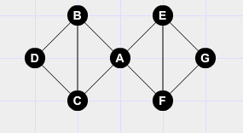

8. Nice example! You should include a sentence or two of explanation: where is the largest clique? Which vertices are in your dominating set? But your picture does give a valid solution.--RK

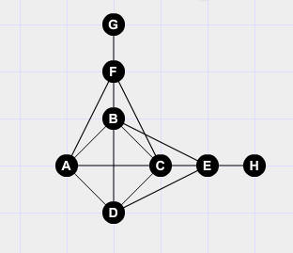

9. I’m not sure this works. Again, you need an explanation. What is the largest clique? What is your partition. I see a K7, and a way to partition the graph into 3 cliques using the K7. I don’t see a way to partition this graph into fewer than 3 cliques. This is where careful explanations of your pictures come in handy! I can’t tell immediately from the picture that you have a valid solution--can you convince me?--RK

